Title:

Solar Light Catcher, Prism Splitter, and Varyated Solar Diode

Field of the Invention:

This present invention relates to a solar cell based light to electricity power generator involving an optical control system and varyated color absorbing solar diodes.

Description of the Prior Art:

Solar cells operate at only 1 light frequency otherwise energy is wasted as heat. Also solar cells are usually naked or have only a reflector based light receiving system.

Abstract:

Light from the sun can be caught by an enormous, relative to the diode matrix, lattice of hexagonal chrome mirrored light directors. Each light director forms a linear hexagonal conical funnel into a hexagonal matrix or spindle of fiber optic channels that directs the light into a 1 fiber optic channel wide array. This array, positioned along the length of a prism, sends the light into a prism, 1 of an array for the enormous mirrored light directors. The prism splits the light into different colors each landing on the respective light receiving diode variance or gradation.

This variance in solar diode receiving frequency is attained with a light catching region of varied amounts of matter doped into said region across a distance to enable different ideal photon absorption frequencies across said distance according to the matter doping variance.

The large diode matrix translates the light into electricity and heat. The excess heat is channeled through water pipes until it can boil the water and push a steam turbine that acts in supplement to the diode matrix.

I claim the following:

1. A solar diode with a light catching region of varied amounts of matter doped into said region across a distance to enable different ideal photon absorption frequencies across said distance according to the matter doping variance.

2. A solar diode with a light catching region of graduated amounts of matter doped into said region across a distance to enable different ideal photon absorption frequencies across said distance according to the matter doping graduations.

3. An array of prisms that separate the light into different colors each landing on the respective light receiving diode variance or gradation.

4. A lattice of conical hexagonal chrome mirrored light directors that direct light onto an array of prisms that separate the light into different colors each landing on the respective light receiving diode variance or gradation.

5. A spindle of fiber optic channels that at the other end from the directed light receiving side forms a narrow feed of light into an element of an array of prisms. These prisms separate the light into different colors each landing on the respective light receiving diode variance or gradation.

6. A lattice of conical hexagonal chrome mirrored light directors. A connected spindle of fiber optic channels that at the other end from said hexagonal chrome mirrored light directors forms a narrow feed of light into an element of an array of prisms. These prisms separate the light into different colors each landing on the respective light receiving diode variance or gradation.

7. Using claims 1-6 with an electricity generating heat engine like a steam turbine.

8. Moving, positioning, and/or angling of said 4th, 5th, and 6th claim’s lattice of conical hexagonal chrome mirrored light directors and/or spindles of fiber optic channels to catch as much light as possible like by angling it towards the Sun or whatever is giving off light.

9. Means to produce all products described in claims 1 through 8.

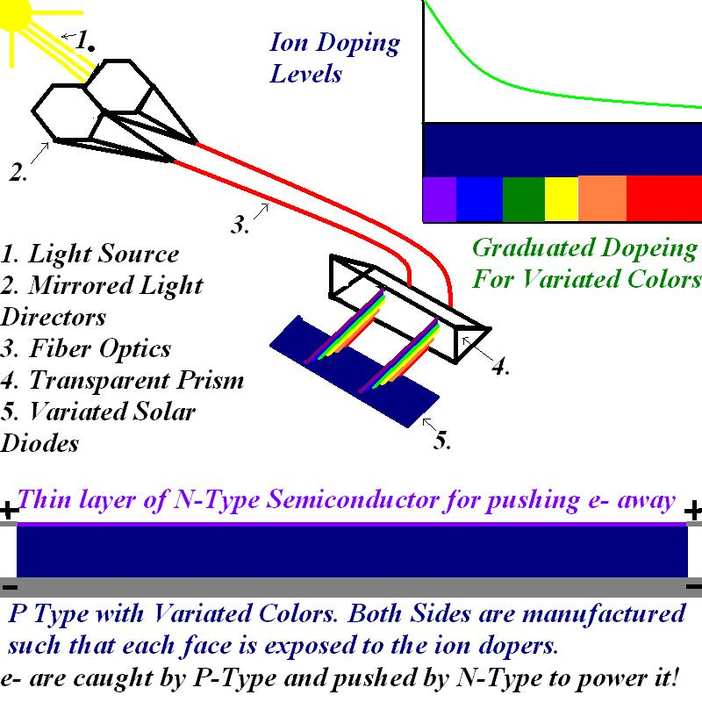
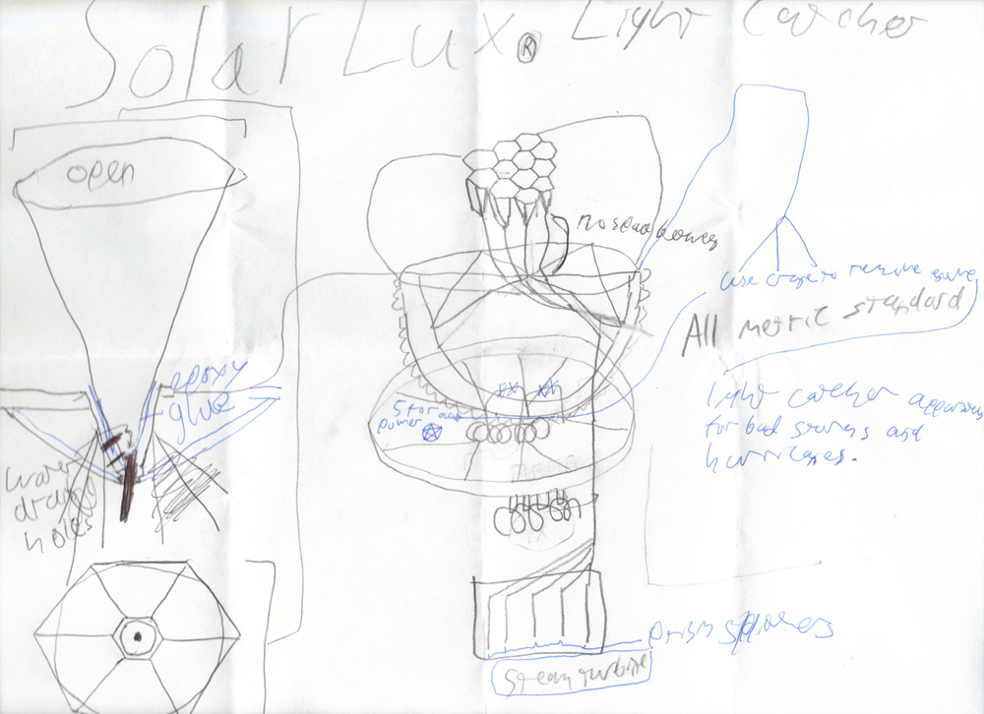

In order that we may live in a more free society the Free World Alliance wishes for congress to pass a bill with the following concessions of the SEC controlled congress to the people of America:

1. Establish the Securities Exchange Network to clamp down on the insider trading corruption and raquteering of the retail markets.

2. The council of 7 shall restore market order and balance the stock market by dictating starting allocations of funds throughout the world.

3. CyMeGen Clinics will provide free health care to all and will implement UV laser seuters in sealing skin.

4. Prostitution shall be legalized.

5. Statutory rape removal.

6. Marijuana and Psycadelics will be legalized.

7. Shoes and constricting clothing will be banned at clubs to end the mob run tease club raqueet.

8. Mental hospital reform will allow arbiters to free people from mental hospitals who were doing nothing more than acting in free speech and free thought. No more shall medicine be forced upon people regardless of their so called sanity.(Believing in mind control caused people to be forced upon lithium and psycafrenics which cause liver failure and insanity over time.)

9. If the above demands are met the E-gold islands will ship enough gold to Fort Knox to not only remove the national debt but also provide a massive surplus for:

10. Development rights to America’s national parks for condominium settlements which do not seriously mar the land and will both provide for expansion, foreign immigration, and make the investment profitable for the gold investors.

